Test Project
  - Web Technologies
  - PHP and JavaScript Module

Submitted by:

Sebastian Häni – CH (Independent Test Project Designer)
Cyril Wanner – CH (Independent Test Project Designer)
Patrick Zahnd – CH (Independent Test Project Designer)

Contents Conteúdo
Contents 2
Introduction 3
Description of project and tasks 3
Phase one – PHP 4
Database design 4
Organizer interface 4
Organizer login and logout 5
Event management 6
Ticket management 9
Session management 10
Channel management 12
Room management 13
Room capacity 14
Attendee API 15
Events overview 15
Event detail 16
Attendee login and logout 17
Event registration 18
Phase two – JavaScript 19
API Setup 19
Introduction 20
Events list 21
Event agenda 22
Session detail 23
Event registration 24
Attendee login 26
Notes 27
Submission Instructions to the Competitor 28
Equipment, machinery, installations, and materials required 29
Marking Scheme 29

Introduction Introdução
The agency responsible for organizing the WorldSkills Conferences needs a new web application helping them to manage the events and allowing attendees to sign up and see all information they need. It should be dynamically built so that it can later be shared with other member organizations which means that multitenancy is an important requirement.
Because this application will grow over time, important requirements are covered by automated tests.
A agência responsável por organizar as Conferências da WorldSkills precisa de um novo aplicativo Web que os ajude a gerenciar os eventos e permitir que os participantes se inscrevam e vejam todas as informações de que precisam. Ele deve ser construído dinamicamente para que posteriormente possa ser compartilhado com outras organizações membros, o que significa que a múltiplos proprietários é um requisito importante.
Como esse aplicativo crescerá com o tempo, requisitos importantes são cobertos por testes automatizados.

Description of project and tasks
Descrição do projeto e tarefas
The project is split into two phases:
- phase one (morning, 3 hrs) for building the backend parts (admin interface and REST-API) using PHP (framework) and database
- phase two (afternoon, 3 hrs) for building the frontend parts (attendee interface) using HTML/CSS/JS (framework) and the REST-API provided for phase two.
O projeto é dividido em duas fases:
• fase um (manhã, 3 horas) para criar as partes de back-end (interface administrativa e REST-API) usando PHP (framework) e banco de dados
• fase dois (tarde, 3 horas) para criar as partes front-end (interface do participante) usando HTML / CSS / JS (framework) e a API REST fornecida para a fase dois.

Phase one – PHP
Fase Um - PHP

Database design
- Use your database (dbYY_competitor_day2) and import the schema/dump provided
- Use seu banco de dados (dbYY_competitor_day2) e importe o esquema / dump fornecido
- Extend your database to be able to store (do not modify/extend any existing table except if it is specifically noted as they will be resetted before every test run)
- Estenda seu banco de dados para poder armazenar (não modifique / estenda nenhuma tabela existente, exceto se for especificamente anotado, pois elas serão redefinidos antes de cada teste)
  - Event ratings
  - Avaliar Evento
    - Attendees should be able to comment and rate events they have attended
    - Os participantes devem poder comentar e avaliar os eventos que participaram
    - Rating should be a full number between 1 and 5, where 1 is the lowest and 5 the highest rating
    - A classificação deve ser um número completo entre 1 e 5, sendo 1 a mais baixa e 5 a mais alta
    - The date and time of the rating should be registered
    - A data e hora da classificação devem ser registradas
  - Session ratings
  - Avaliar Sessão
    - Additional to the event rating, attendees should be able to rate sessions they have attended
    - Além da classificação do evento, os participantes devem poder avaliar as sessões em que participaram
    - Rating should be a full number between 1 and 5, where 1 is the lowest and 5 the highest rating
    - A classificação deve ser um número completo entre 1 e 5, sendo 1 a mais baixa e 5 a mais alta
    - The date and time of the rating should be registered
    - A data e hora da classificação devem ser registradas
- Your additional tables need to follow the third normal form.
- Suas tabelas adicionais precisam seguir a terceira forma normal.

Organizer interface
Interface da Organização
Create an organizer interface (Server Side Rendered using a PHP Framework) using the templates provided to
- manage events, sessions, channels, rooms and tickets (create, read, update)
- create a bar chart to see the occupancy rates of all rooms
- create dynamic ticket prices
- support multiple tenants
Because different organizers will use this backend, keep security in mind. It should not be possible to access events of other organizers or update events of other organizers.
Crie uma interface da organização (Lado do Servidor Renderizado usando um Framework PHP) usando os modelos fornecidos para
• gerenciar eventos, sessões, canais, salas e tickets (criar, ler, atualizar)
• criar um gráfico de barras para ver as taxas de ocupação de todos as salas
• criar preços dinâmicos de ingressos
• suporte a vários proprietários
Como diferentes organizadores usarão esse back-end, lembre-se da segurança. Não deve ser possível acessar eventos de outros organizadores ou atualizar eventos de outros organizadores.

Organizer login and logout Login e Logout do Organizador
Because registering as a new organizer is not within the scope of this project, please update the first two organizers in the provided dump so that it is possible to log in with the following credentials:
Como o registro de um novo organizador não está no escopo deste projeto, atualize os dois primeiros organizadores no dump fornecido para que seja possível efetuar login com as seguintes credenciais:
- Email: demo1@worldskills.org Password: demopass1
- Email: demo2@worldskills.org Password: demopass2
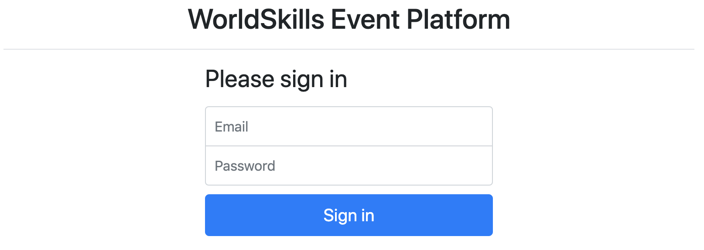
Specification: Especificação:
Feature: A1 – Log in and log out as an organizer: As an organizer, I would like to log in and log out to the event platform so that I can access the functionality of the platform.
Funcionalidade: A1 - Efetue login e logout como organizador: Como organizador, gostaria de efetuar login e logout na plataforma de eventos para que eu possa acessar a funcionalidade da plataforma.
Scenario: A1a - Organizer login ok
Given I am on the "login" page
When I enter the specified email and password for an organizer
And press the "Sign in" button
Then I am forwarded to the organizer area
And organizator name and "Sign out" button become visible in the header
And page "Manage events" becomes visible

Scenario: A1b - Organizer login fail
Given I am on the "login" page
When I enter a wrong email and password combination for an organizer
or use login information of an attendee instead of an organizer
And press the "Sign in" button
Then I stay on the "login" page
And I see an error message "Email or password not correct"

Scenario: A1c - Organizer logout
Given I am logged in
When I press the "Sign out" button
Then I am forwarded to the "login" page
And organizator name and logout button and admin functions disappear
And I cannot reach the previous page by going back

Event management Gerenciamento do Evento
Organizers should be able to save all information about an event and its sessions in the database. Every organizer account can only see and edit its own events. The organizer may have zero or many events.
Os organizadores devem poder salvar todas as informações sobre um evento e suas sessões no banco de dados. Cada conta do organizador só pode ver e editar seus próprios eventos. O organizador pode ter zero ou muitos eventos.
Specification: Especificação:
Feature: A2 - Manage events: As an organizer I want to manage events so attendees can find events
Requisito: A2 - Gerenciar eventos: como organizador, quero gerenciar eventos para que os participantes possam encontrar eventos
Scenario: A2a – List all events
Given I am logged in
And I am on the "Manage events" page
Then I see a list of all events created by the current organizer sorted
ascendingly by their date
And I see the total number of registrations for every event

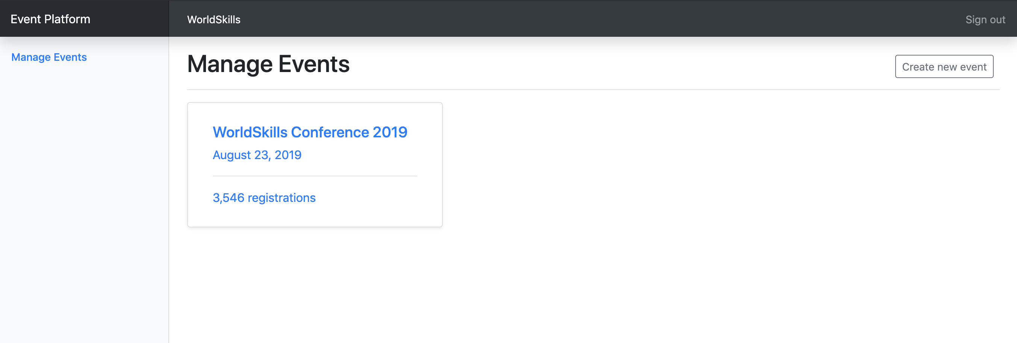

Scenario: A2b - Show form for new event
Given I am logged in
And I am on the "Manage events" page
When I press "Create new event"
Then a form to enter event information appears

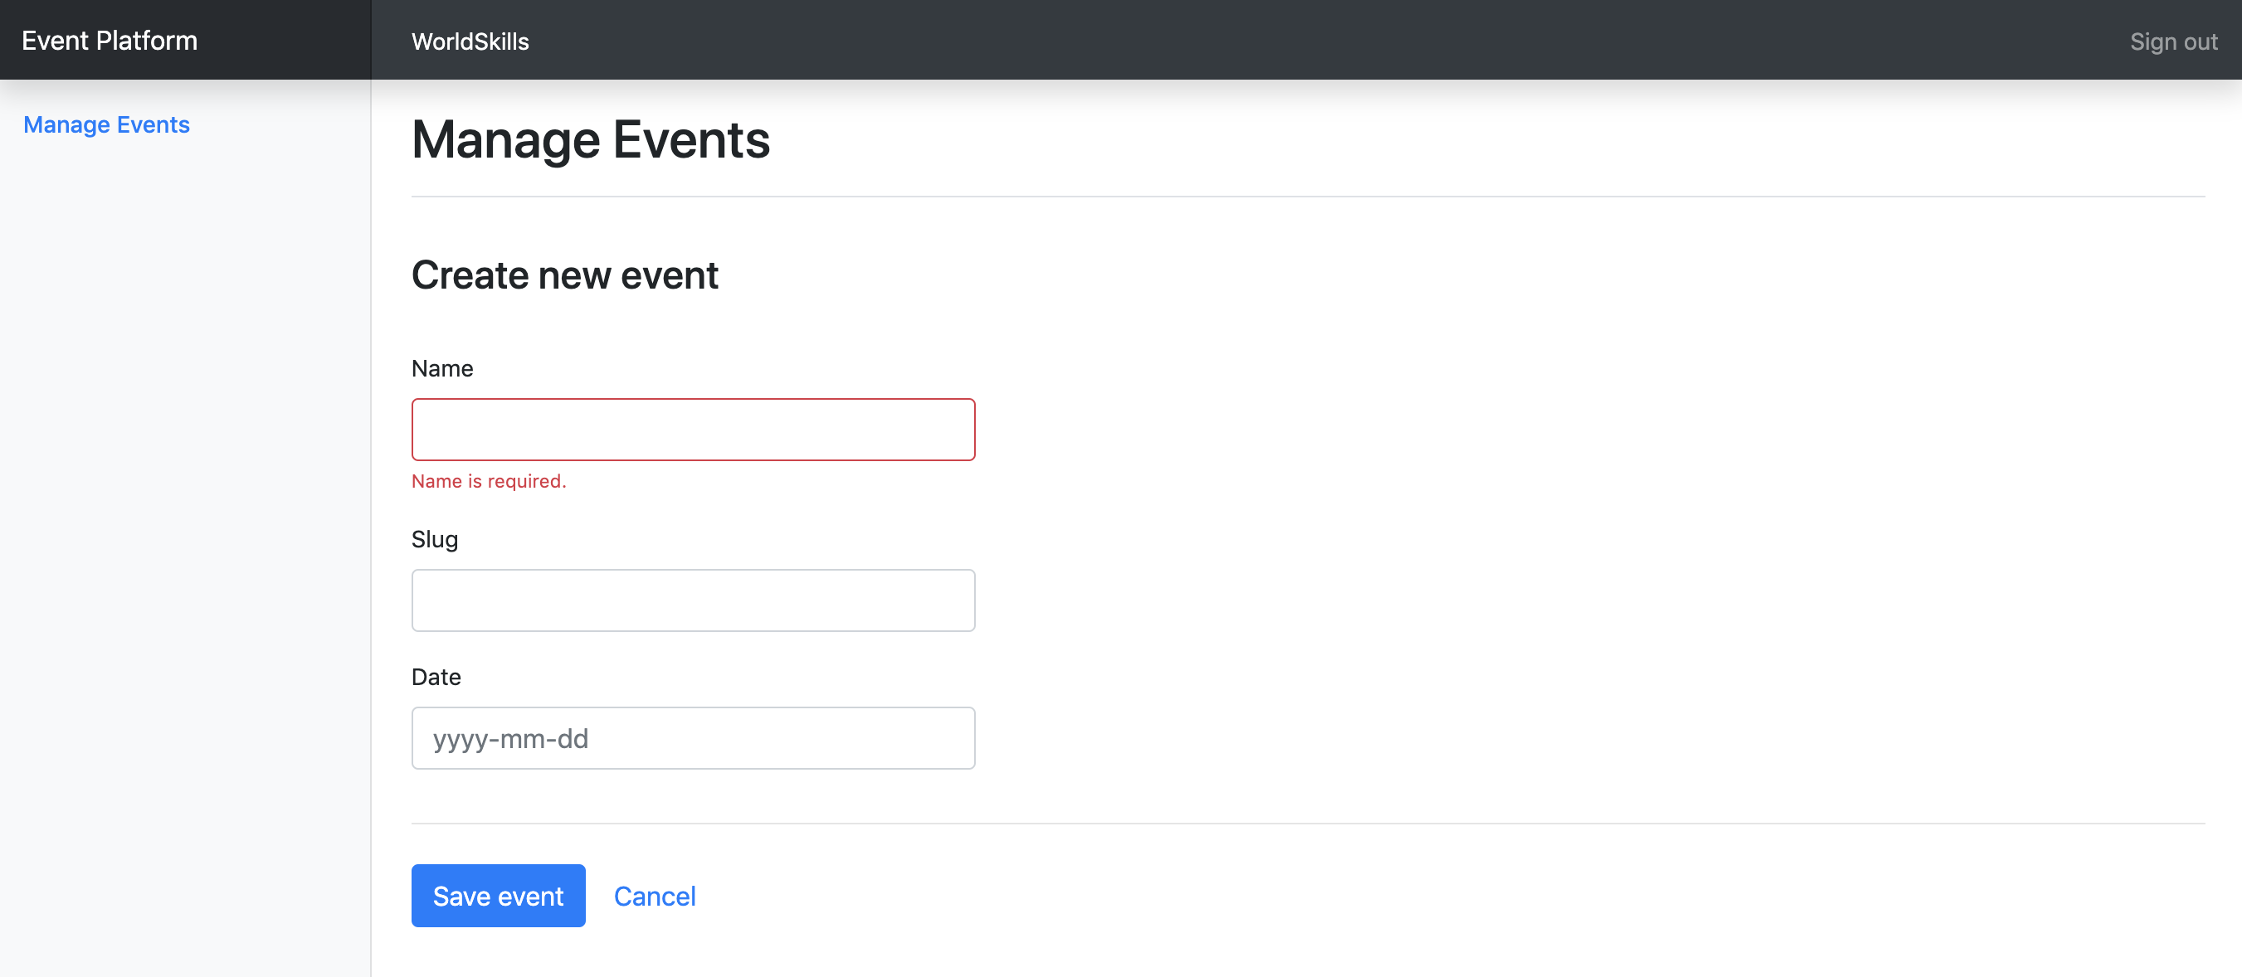

Scenario: A2c - Enter information for a new event
Given a form to enter event information is shown
When I enter info for the event (all fields required)
And I press "Save event"
Then the event is saved into the database
And I am redirected to the detail page for the newly created event
And a success message "Event successfully created" is shown

Scenario: A2d – Enter already used slug for a new event
Given a form to enter event information is shown
When I enter info for the event and use a slug which is already used by
another event of the same organizer
And I press "Save event"
Then the event is not saved into the database
And an error message "Slug is already used" is shown
And my previously submitted input data is not lost

Scenario: A2e – Enter invalid slug for an event
Given a form to enter event information is shown
When I enter an invalid slug for the event
And I press "Save event"
Then the event is not saved into the database
And an error message "Slug must not be empty and only contain a-z, 0-9 and
'-'" is shown

Scenario: A2f - Show form for updating event
Given I am logged in
And I am on the detail page of an event
When I press "Edit event"
Then a form to update event information appears

Scenario: A2g – Update event information
Given a form to update information of an existing event
When I change the prefilled old event information to new values
And I press "Save event"
Then the updated event is saved into the database
And I am redirected to the detail page for the updated event
And a success message "Event successfully updated" is shown

Scenario: A2h – Show event detail
Given I am on the "Manage events" page
And I click on an event in the list
Then I am forwarded to the detail page on this event
And can see all basic information as well as all relations to the available
rooms, channels, sessions and tickets

Ticket management Gerenciamento de Ingressos
For each event, organizers want to create different ticket types. Tickets can have, but don’t need, one validity rule which can be one of:
- only purchasable until a given date (e.g. book before July 30, 2019 for an early bird ticket)
- only a defined amount of tickets is available (e.g. max 50 VIP tickets)
Please check existing records in the provided dump to see how validity rules should be stored.
Para cada evento, os organizadores desejam criar diferentes tipos de ingresso. Os ingressos podem ter, mas não precisam, uma regra de validade que pode ser uma das seguintes:
• apenas pode ser comprado até uma determinada data (por exemplo, register-se antes de 30 de julho de 2019 para um ingresso antecipado)
• apenas uma quantidade definida de ingressos está disponível (por exemplo, no máximo 50 ingressos VIP)
Por favor, verifique os registros existentes no dump fornecido para ver como as regras de validade devem ser armazenadas.
Specification: Especificação:
Feature: A3 – Manage tickets: As an organizer I want to manage tickets that attendees can buy in the frontend
Requisito: A3 - Gerenciar tickets: como organizador, quero gerenciar os ingressos que os participantes podem comprar no frontend

Scenario: A3a – Show form for new ticket
Given I am on the detail page of an event
And I press "Create new ticket"
Then a form to enter ticket information appears

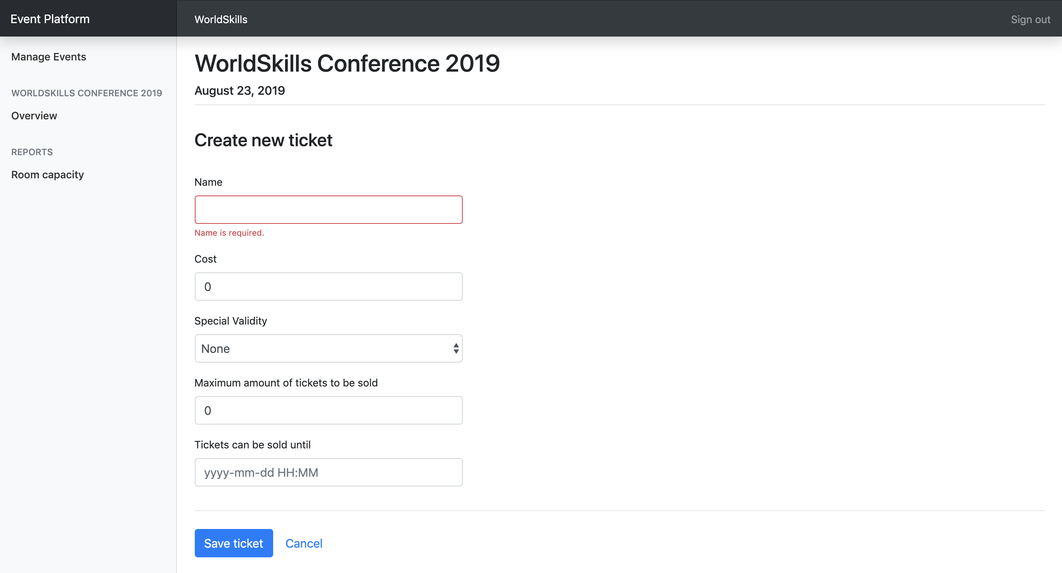

Scenario: A3b – Enter information for a new ticket
Given a form to enter session information is shown
When I enter information for the ticket (name and cost field are required, also any field that is related to the selected special validity rule)
And I press "Save ticket"
Then the ticket is saved into the database
And I am redirected to the detail page of the event it is assigned to
And a success message "Ticket successfully created" is shown

Session management Gerenciamento da Sessão
For every event, organizers want to be able to list the current sessions and have the possibility to create new ones. Sessions are always assigned to a room which can not have another session during that time. Sessions are one of these two types:
- talk: A speaker presents a talk. Talks are included in the conference ticket and do not cost extra.
- workshop: A speaker holds a hand-on workshop with its attendees. Workshops can cost extra.
Para cada evento, os organizadores querem poder listar as sessões atuais e ter a possibilidade de criar novas sessões. As sessões são sempre atribuídas a uma sala que não pode ter outra sessão durante esse período. As sessões tem um desses dois tipos:
• conversa: um orador apresenta uma palestra. As conversas estão incluídas no ingresso da conferência e não tem custo extra.
• workshop: Um palestrante realiza um workshop prático com seus participantes. Workshops podem custar mais.
Specification: Especificação:
Feature: A4 – Manage sessions: As an organizer I want to manage sessions that attendees can sign up for
Requisito: A4 - Gerenciar sessões: como organizador, quero gerenciar as sessões nas quais os participantes podem se inscrever

Scenario: A4a – Show form for new session
Given I am on the detail page of an event
And I press "Create new session"
Then a form to enter session information appears

Scenario: A4b – Enter information for a new session
Given a form to enter session information is shown
When I enter information for the session (all fields, except cost, required)
And I press "Save session"
Then the session is saved into the database
And I am redirected to the detail page of the event it is assigned to
And a success message "Session successfully created" is shown

Scenario: A4c – Enter invalid information for a new session – room booked
Given a form to enter session information is shown
When I choose a room which already has another session at the same time
And I press "save session"
Then the session is not saved into the database
And an error message "Room already booked during this time" is shown
And my previously submitted input data is not lost

Scenario: A4d – Show form for updating session
Given I am on the detail page of an event
And I click on the name of a session
Then a form to update session information appears

Scenario: A4e – Update session information
Given a form to update information of an existing session
When I change the prefilled old event information to new values
And I press "Save session"
Then the updated session is saved into the database
And I am redirected to the detail page of the event it is assigned to
And a success message "Session successfully updated" is shown

Channel management Gerenciamento de Canal
A channel is used to group multiple sessions by a topic, for example management or user experience. Channels are assigned to exactly one event.
Um canal é usado para agrupar várias sessões por um tópico, por exemplo, gerenciamento ou experiência do usuário. Os canais são atribuídos a exatamente um evento.
Specification: Especificações:
Feature: A5 - Manage channels: As an organizer I want to manage channels of an event so sessions can get assigned to them
Funcionalidade: A5 - Gerenciar canais: como organizador, quero gerenciar os canais de um evento para que as sessões possam ser atribuídas a eles

Scenario: A5a – Show form for new channel
Given I am on the detail page of an event
And I press "Create new channel"
Then a form to enter channel information appears

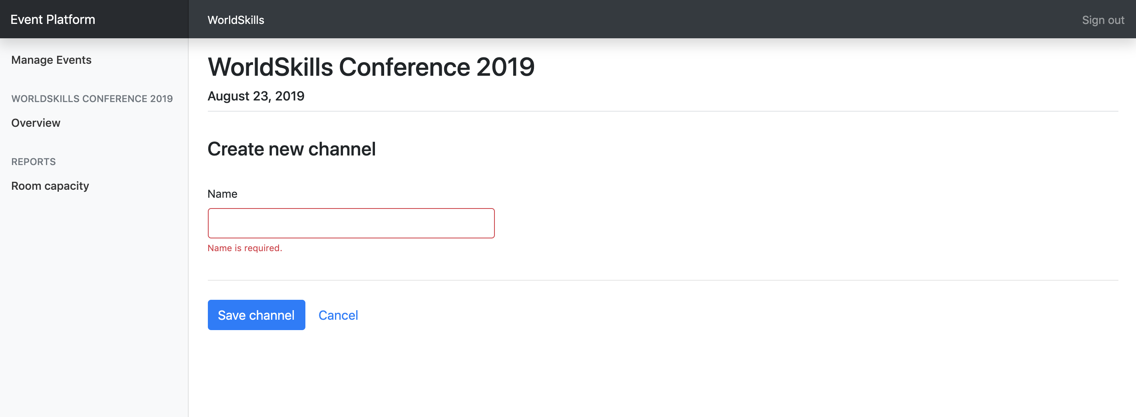

Scenario: A5b – Enter information for a new channel
Given a form to enter channel information is shown
When I enter information for the channel (all fields required)
And I press "Save channel"
Then the channel is saved into the database
And I am redirected to the detail page of the event it is assigned to
And a success message "Channel successfully created" is shown

Room management Gerenciamento de Salas
A room is assigned to exactly one channel and can have exactly one session at a time.
Specification: Especificação:
Feature: A6 – Manage rooms: As an organizer I want to manage rooms which I can later assign to sessions
Funcionalidade: A6 - Gerenciar salas: Como organizador, quero gerenciar salas que depois posso associar para sessões

Scenario: A6a – Show form for new room
Given I am on the detail page of an event
And I press "Create new room"
Then a form to enter room information appears

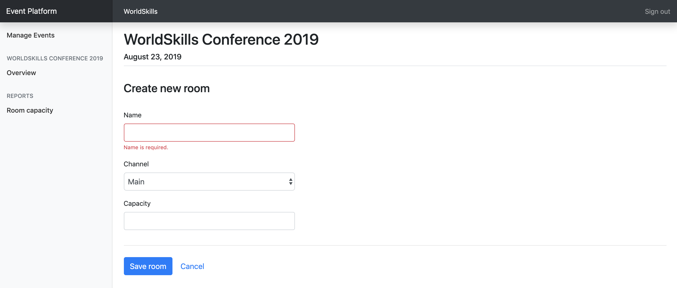

Scenario: A6b – Enter information for a new room
Given a form to enter room information is shown
When I enter information for the room (all fields required)
And I press "Save room"
Then the room is saved into the database
And I am redirected to the detail page of the event it is assigned to
And a success message "Room successfully created" is shown

Room capacity Capacidade da Sala
Organizers want to see an overview of all sessions with information about the room capacity and number of attendees. With this information, they can see if a room is reaching its full capacity.
Please note that for all sessions of type talk, attendees don't need a separate ticket. For sessions of type workshop, they need a separate ticket.
Os organizadores querem ter uma visão geral de todas as sessões com informações sobre a capacidade da sala e o número de participantes. Com essas informações, eles podem ver se uma sala está atingindo sua capacidade total.
Por favor, note que para todas as sessões do tipo conversa, os participantes não precisam de um ticket separado. Para sessões do tipo workshop, eles precisam de um ticket separado.
Specification: Especificação:
Feature: A7 – Room overview: As an organizer I want to see an overview of the sessions with the room capacity and number of attendees
Funcionalidade: A7 - Visão geral da sala: Como organizador, quero ter uma visão geral das sessões com a capacidade da sala e o número de participantes

Scenario: A7a – Show room overview
Given I am on the detail page of an event
When I press the link "Room capacity" in the sidebar
Then I see a bar chart displaying sessions along the horizontal axis,
while the y-axis is showing the room capacity superimposed with the
registered amount of attendees

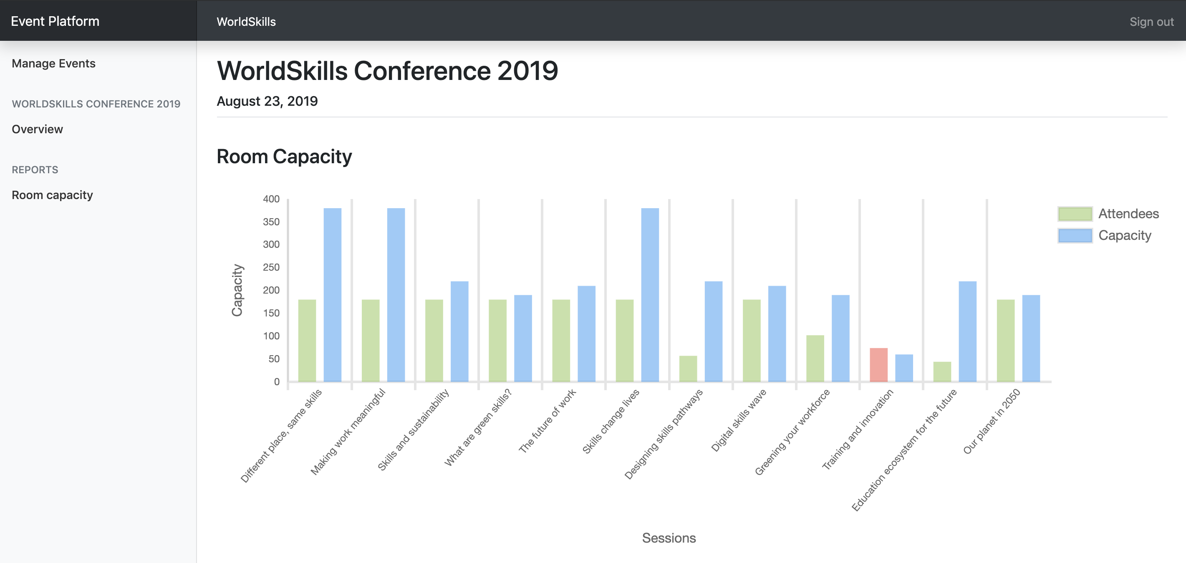

Scenario: A7b – Room capacity exceeded
Given I am on the "Room capacity" page
When I have a room which exceeds its capacity
Then I see the visitors bar highlighted with a red color instead of green

Attendee API
Create a RESTful API (http://<hostname>/XX_JS-PHP_A/api/v1/…) to
- login and logout as an attendee
- read all upcoming events
- see the agenda for an event
- sign up and purchase a ticket for an event
Crie uma API RESTful (http: // <hostname> / XX_JS-PHP_A / api / v1 /…) para
• login e logout como participante
• leia todos os próximos eventos
• veja a agenda de um evento
• inscreva-se e compre um ingresso para um evento

PHPUnit tests Testes da PHPUnit
Tests for the PHP API are distributed with the mediafiles. Please see the following instructions to set them up and configure on your own server.
Testes para a API do PHP são distribuídos com os arquivos de media. Por favor, consulte as instruções a seguir para configurá-las e roda-las em seu próprio servidor.
Setup:
- Upload the API tests to your server
- Configure the .env file of the API tests and provide correct database credentials and the URL where your API is available.
1. Carregue os testes da API no seu servidor
2. Configure o arquivo .env dos testes da API e forneça as credenciais corretas do banco de dados e a URL em que sua API está disponível.
Running the tests: Rodando os testes:
Execute the following command on the server inside the directory of the api tests:
Execute o seguinte comando no servidor dentro do diretório dos testes da API:
composer test
To only run a single test, you can use the following command for example:
Para executar apenas um único teste, você pode usar o seguinte comando, por exemplo:
composer test -- --filter B2EventDetailTest

Additional information for the REST-API tests/specification: the body contains some static example data, adjust it to fit the requirements. Placeholder parameters in the URL are marked with curly braces: {slug}
The tests are referenced by its function name [-> test<scenario-id><text>].
The order of properties in objects does not matter, but the order of items in an array does.
Informações adicionais para os testes / especificação REST-API: o corpo contém alguns dados de exemplo estáticos, ajuste-os para atender aos requisitos. Os parâmetros de espaço reservado no URL são marcados com chaves: {slug}
Os testes são referenciados pelo nome da função [-> test <scenario-id> <text>].
A ordem das propriedades em objetos não importa, mas a ordem dos itens em uma lista é importante.

Events overview Visualização de Eventos
When an attendee lands on the index page of the application, he will get a list with all upcoming events across all organizers. Events should be ordered ascendilgly by their date.
Quando um participante chega na página de índice do aplicativo, ele recebe uma lista com todos os eventos futuros em todos os organizadores. Os eventos devem ser ordenados ascendendamente por sua data.
Specification: Especificação:
Feature: B1 – Read events: As a visitor I want to read the public data of all upcoming events so that I can display them in a list
Funcionalidade: B1 - Eventos de leitura: Como visitante, quero ler os dados públicos de todos os eventos futuros para poder exibi-los em uma lista

Scenario: B1a – Read all upcoming events
Request
URL: /api/v1/events
Method: GET
Header:
Body: -
Response
If success [-> testB1aGetEvents]
Header: Response code: 200
Body: {"events": [{"id": 1, "name": "someText", "slug": "some-text", "date": "2019-08-15", "organizer": {"id": 1, "name": "someText", "slug": "some-text"}}]}

Event detail Detalhes do Evento
When an event is selected, all information of the selected event should be returned in the same endpoint.
If a session has no cost or a ticket no description, NULL will be used.
The description of a ticket is generated as following:
- NULL if no special validity rule set
- "Available until {month} {day}, {year}" if special validity rule "date" is used
(example: "Available until September 1, 2019")
- "X tickets available" if special validity rule "amount" is used
(example: "30 tickets available" where 30 is the total amount of tickets and not the remaining ones)
Quando um evento é selecionado, todas as informações do evento selecionado devem ser retornadas no mesmo endpoint.
Se uma sessão não tiver custo ou um ticket não tiver descrição, NULL será usado.
A descrição de um ticket é gerada da seguinte forma:
- NULL se não houver um conjunto de regras de validade especial
- "Disponível até {mês} {dia}, {ano}" se for usada a regra de validade especial "date"
(exemplo: "Disponível até 1 de setembro de 2019")
- "X tickets disponíveis" se a regra de validade especial "amount" for usada
(exemplo: "30 ingressos disponíveis", onde 30 é o total de ingressos e não os restantes)
Specification: Especificação:
Feature: B2 - Read event: As a visitor I want to read all information about an event
Funcionalidade: B2 - Evento de leitura: Como visitante, quero ler todas as informações sobre um evento

Scenario: B2a – Read all detail information of a single event
Request
URL: /api/v1/organizers/{organizer-slug}/events/{event-slug}
Method: GET
Header:
Body: -
Response
If success [-> testB2aGetEventDetail | testB2aTicketValidity]
Header: Response code: 200
Body: {"id": 1, "name": "someText", "slug": "some-text", "date": "2019-08-15", "channels": [{"id": 1, "name": "someText", "rooms": [{"id": 1, "name": "someText", "sessions": [{"id": 1, "title": "someText", "description": "someText", "speaker": "someText", "start": "2019-08-15 10:00:00", "end": "2019-08-15 10:45:00", "type": "workshop", "cost": 50|null}]}]}], "tickets": [{"id": 1, "name": "someText", "description": "Available until July 7, 2019"|null, "cost": 199.99, "available": true}]}
If event does not exist or was not created by the organizer [-> testB2aGetInvalidEvent]
Header: Response code: 404
Body: {"message": "Event not found"}
If organizer does not exist [-> testB2aGetInvalidOrganizer]
Header: Response code: 404
Body: {"message": "Organizer not found"}

Attendee login and logout Login e Logout do Participante
After signup (which is not within the scope of this project), attendees get assigned a random 6 characters long registration code which they need when entering an event. To avoid requiring yet another password, this registration code is also used for logging the user in on the website, together with his lastname as his login credentials. The registration code is shared across all events and is not only valid for a single event.
For testing purposes, the registration code and last name can be seen in the database dump.
On a successful login, data of the loggedin attendee gets returned together with a token which can be sumitted with subsequent requests. For simplicity, the token is the username md5-hashed and is valid until the logout endpoint is called.
Após a inscrição (que não está no escopo deste projeto), os participantes recebem um código de registro aleatório de 6 caracteres de que precisam para acessar um evento. Para evitar a necessidade de outra senha, esse código de registro também é usado para registrar o usuário no site, junto com seu sobrenome como suas credenciais de login. O código de registro é compartilhado em todos os eventos e não é válido apenas para um único evento.
Para fins de teste, o código de registro e o sobrenome podem ser vistos no dump do banco de dados.
Em um login bem-sucedido, os dados do participante registrado são retornados junto com um token que pode ser enviado com solicitações subsequentes. Para simplificar, o token é o nome de usuário md5-hashed e é válido até que o endpoint de logout seja chamado.
Specification: Especificação:
Feature: B3 - Login and Logout as atteendee: As a visitor I want to login/logout so that I can attend an event and see my registrations
Funcionalidade: B3 - Login e Logout como visitante: Como visitante, quero fazer o login / logout para poder participar de um evento e ver minhas inscrições.

Scenario: B3a - Attendee login
Request
URL: /api/v1/login
Method: POST
Header:
Body: {"lastname": "someText", "registration_code": "someText"}
Response
If success [-> testB3aCorrectLogin|SameLastname|SameRegistrationCode]
Header: Response code: 200
Body: {"firstname: "someText", "lastname": "someText", "username": "someText", "email": "someText", "token": "AUTHORIZATION_TOKEN"} (md5 hashed username, valid until logout)
If user login info not correct [-> testB3aInvalidLastname|RegistrationCode|Request]
Header: Response code: 401
Body: {"message": "Invalid login"}

Scenario: B3b – Attendee logout
Request
URL: /api/v1/logout?token={AUTHORIZATION_TOKEN}
Method: POST
Header:
Body: -
Response
If success [-> testB3bLogout]
Header: Response code: 200
Body: {"message": "Logout success"}
If invalid token [-> testB3bInvalidToken | testB3bAlreadyLoggedOut]
Header: Response code: 401
Body: {"message": "Invalid token"}

Event registration Registro em um Evento
Users will register and buy a ticket with this endpoint. The different ticket validity rules (date or amount) should be validated. Registrations should be sorted ascendingly by their id.
Os usuários se registrarão e comprarão um ingresso com esse endpoint. As diferentes regras de validade do ingresso (data ou valor) devem ser validadas. As inscrições devem ser classificadas de forma crescente por seu id.
Specification: Especificação:
Feature: B4 – Event registration: As a visitor I want to register for an event
Funcionalidade: B4 - Registo do evento: Como visitante, quero registar-me para um evento

Scenario: B4a – New event registration
Request
URL: /api/v1/organizers/{organizer-slug}/events/{event-slug}/registration?token={AUTHORIZATION_TOKEN}
Method: POST
Header:
Body: {"ticket_id": 1, "session_ids": [1, 2, 3]} (session_ids is optional)
Response
If success [-> testB4aCorrectRegistration]
Header: Response code: 200
Body: {"message": "Registration successful"}
If user is not logged in or token is invalid [-> testB4aLoggedOut]
Header: Response code: 401
Body: {"message": "User not logged in"}
If user already registered for this event [-> testB4aAlreadyRegistered]
Header: Response code: 401
Body: {"message": "User already registered"}
If ticket is not available anymore [-> testB4aInvalidTicket]
Header: Response code: 401
Body: {"message": "Ticket is no longer available"}

Scenario: B4b – Get registrations of a user
Request
URL: /api/v1/registrations?token={AUTHORIZATION_TOKEN}
Method: GET
Header:
Body: -
Response
If success [-> testB4bGetRegistrations | testB4bNewRegistration]
Header: Response code: 200
Body: {"registrations": [{"event": {"id": 1, "name": "someText", "slug": "some-text", "date": "2019-08-15", "organizer": {"id": 1, "name": "someText", "slug": "some-text"}}, "session_ids": [1, 2, 3]}]}
If user is not logged in or token is invalid [-> testB4bLoggedOut]
Header: Response code: 401
Body: {"message": "User not logged in"}

Phase two – JavaScript
Fase dois - JavaScript

API Setup
The API needed for this part will be provided after lunch and can be set up with the following instructions. In case you want to start with part two before lunch, you have to use your own API from part one.
A API necessária para esta parte será fornecida após o almoço e pode ser configurada com as seguintes instruções. Caso você queira começar com a parte dois antes do almoço, você precisa usar sua própria API na primeira parte.
Automated setup: Configuração automática:
Connect to your server through SSH and execute the following command (in your home directory):
Conecte-se ao seu servidor por meio do SSH e execute o seguinte comando (em seu diretório pessoal):
setup-api
This will automatically set up the API and database on your server. After completion, the API is available at http://XX.skill17.com/day2-afternoon/ (XX is your workstation number).
The API is implemented according to the specification of the Attendees API in part one.
Isso irá configurar automaticamente a API e o banco de dados no seu servidor. Após a conclusão, a API estará disponível em http://XX.skill17.com/day2-afternoon/ (XX é o número da sua estação de trabalho).
A API é implementada de acordo com a especificação da API de participantes na primeira parte.
Manual setup: Configuração Manual:
The manual setup should only be done in case the automatic setup fails.
A configuração manual só deve ser feita em caso de falha na configuração automática.
- Download the API from http://wsi.skill17.com/day2_afternoon_api.zip (only available in the afternoon)
- Upload it to your server and unzip it into the folder /home/competitor/www/day2-afternoon (ensure that the unzipped files files are directly located in the folder /home/competitor/www/day2-afternoon and not in another subfolder)
- Create a new database called day2_afternoon and import the provided dump from part one
- The API is now available at http://XX.skill17.com/day2-afternoon/ (XX is your workstation number)
1. Faça o download da API em http://wsi.skill17.com/day2_afternoon_api.zip (disponível apenas no período da tarde)
2. Faça o upload para o seu servidor e descompacte-o na pasta / home / concorrente / www / day2-afternoon (certifique-se de que os arquivos descompactados estejam localizados diretamente na pasta / home / concorrente / www / day2- afternoon e não em outro subpasta)
3. Crie um novo banco de dados chamado day2_afternoon e importe o dump fornecido da primeira parte
4. A API está agora disponível em http://XX.skill17.com/day2-afternoon/ (XX é o número da sua estação de trabalho)

Introduction Introdução
Using the RESTful API (all data coming/going into database), create a frontend for attendees to browse information about the events, login/logout and register for an event. During registration, it should be possible to add additional workshops they want to attend.
The RESTful API supports POST requests with JSON or FormData bodies, but the correct request headers need to be set accordingly to the used body type.
Interaction should show error/feedback messages based on response from the API where appropriate. Also, an error page should be shown when accessing an invalid URL.
Browsing all data is public and no user is required. But as soon as they want to register for an event, they need to be signed in.
Refreshing a page should always display the same page and it must be possible to share a page by URL so that all state is kept in the URL.
The layout should follow mockups exactly. The position of elemenst in design should be same as mockups.
Usando a API RESTful (todos os dados que chegam / vão ao banco de dados), crie um frontend para os participantes procurarem informações sobre os eventos, efetuar login / logout e registrar-se em um evento. Durante o registro, deve ser possível adicionar workshops adicionais que eles querem participar.
A API RESTful suporta solicitações POST com corpos JSON ou FormData, mas os cabeçalhos de solicitação corretos precisam ser definidos de acordo com o tipo de corpo usado.
A interação deve mostrar mensagens de erro / feedback com base na resposta da API, quando apropriado. Além disso, uma página de erro deve ser exibida ao acessar um URL inválido.
A navegação de todos os dados é pública e nenhum usuário é necessário. Mas assim que eles quiserem se inscrever em um evento, eles precisam fazer login.
A atualização de uma página deve sempre exibir a mesma página e deve ser possível compartilhar uma página por URL para que todo o estado seja mantido na URL.
O layout deve seguir os mockups exatamente. A posição do elementos no design deve ser a mesma dos mockups.

The yellow bubbles in the mockups show classes and ids which have to be used for those elements to allow running automated tests. The yellow bubbles are not part of the design and do not have to be displayed in the browser.
As bolhas amarelas nos mockups mostram classes e ids que devem ser usados para esses elementos para permitir a execução de testes automatizados. As bolhas amarelas não fazem parte do design e não precisam ser exibidas no navegador.
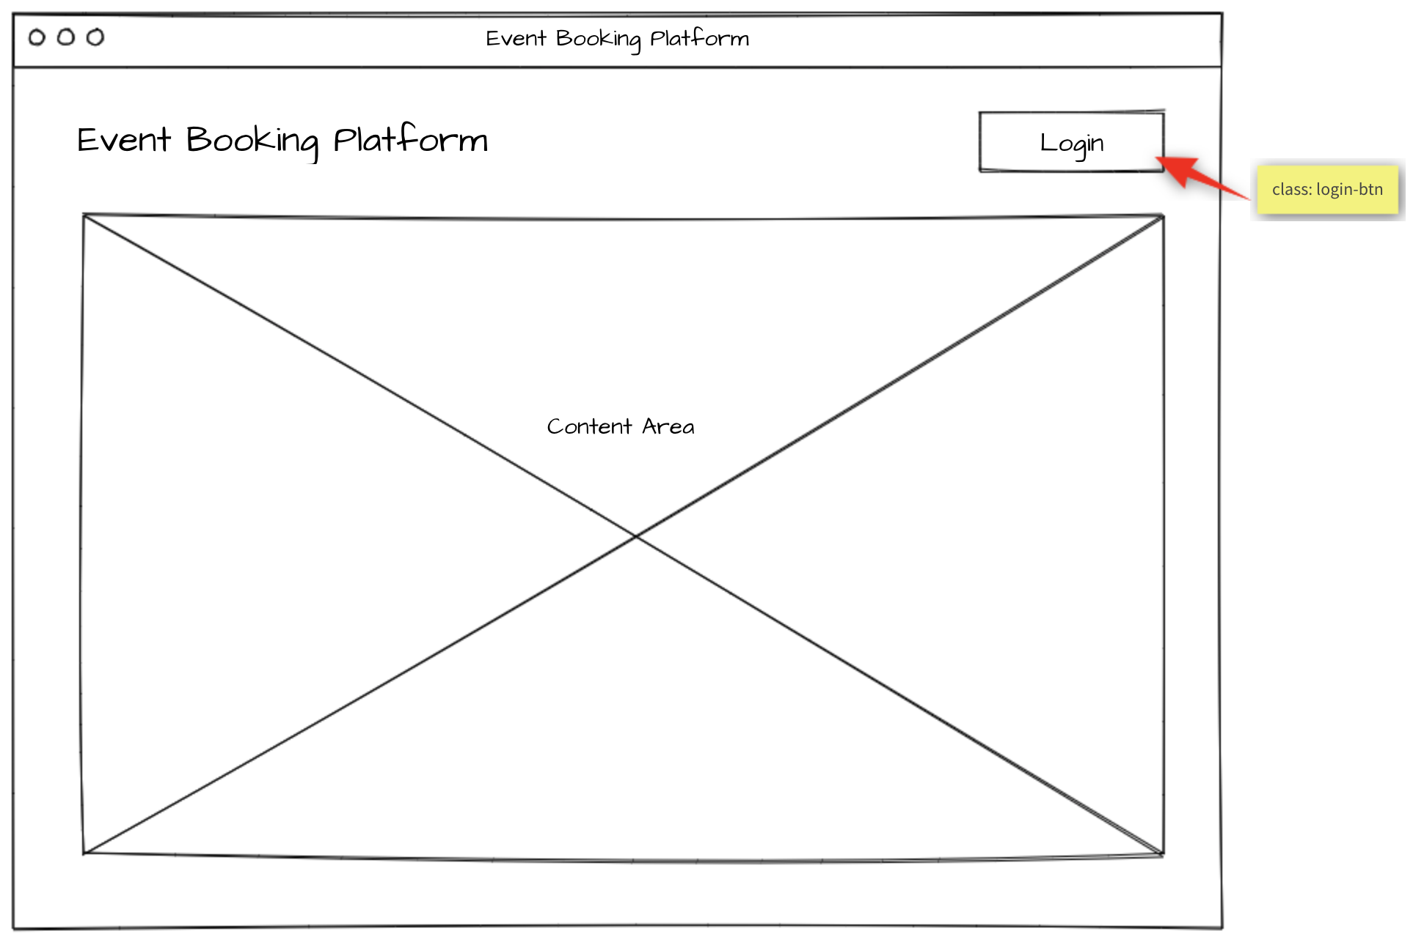

Events list Lista de Eventos
When accessing the index page, all upcoming events are displayed with their organizer name and the date it takes place. By selecting an event, the event agenda will be shown.
Ao acessar a página de índice, todos os próximos eventos são exibidos com o nome do organizador e a data em que ele ocorre. Ao selecionar um evento, a agenda do evento será exibida.
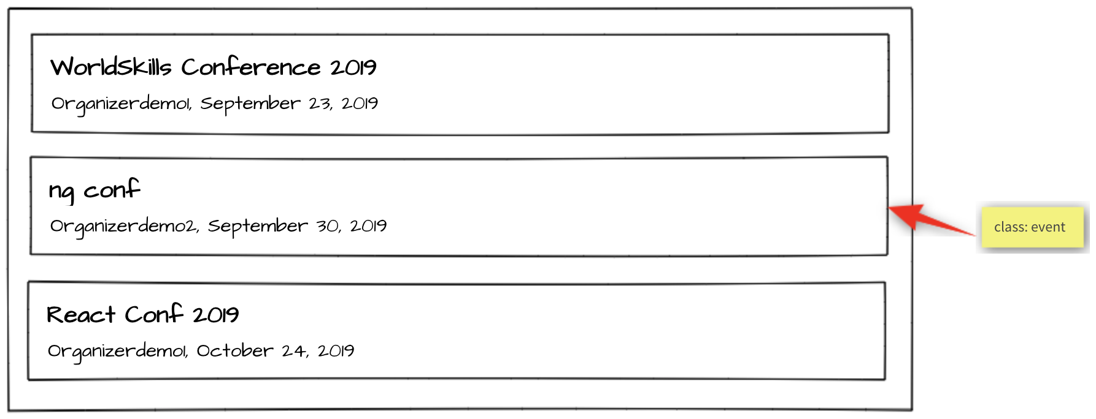
Specification: Especificação:
Feature C1 - List upcoming events: As an attendee, I want to see what events I can attend.
Requisito C1 - Listar os próximos eventos: como participante, quero ver quais eventos posso participar.

Scenario: C1a - List upcoming events
Given I am on the home page
Then I see a chronologically ordered list of upcoming events across all
organizers
And I can click on an event

Event agenda Agenda de Eventos
The agenda of the selected event is shown. If the user is logged in and is already registered for this event, all sessions with type talk are highlighted with a green border since they are automatically included in every event registration. Additionally, if the user signed up for addition sessions of type workshop, they will also be highlighted with a green border.
A agenda do evento selecionado é mostrada. Se o usuário estiver logado e já estiver registrado para este evento, todas as sessões com o tipo conversa serão destacadas com uma borda verde, já que elas são automaticamente incluídas em todos os registros de eventos. Além disso, se o usuário se inscrever para sessões de adição do tipo workshop, elas também serão destacadas com uma borda verde.
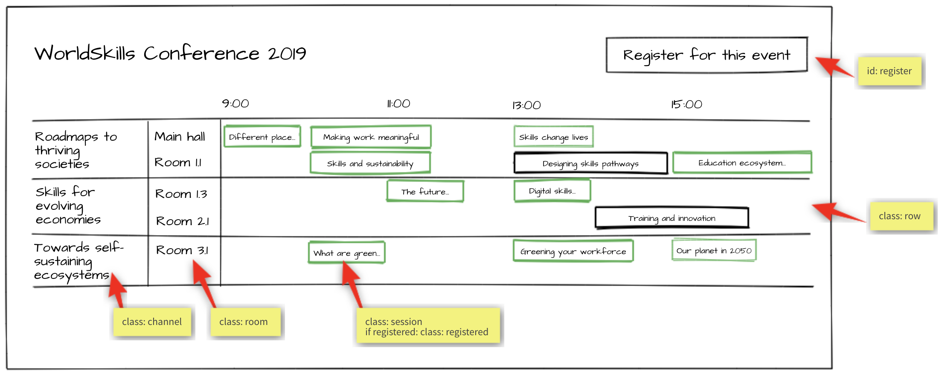
Specification: Especificação:
Feature C2 - Display event agenda: As an attendee, I want to see what sessions are within an event.
Requisito C2 - Exibir agenda de eventos: como participante, quero ver quais sessões estão em um evento.

Scenario: C2a - Display channels
Given I am on an event detail page
Then I see the channels of the event forming horizontal swimlanes
And the channels contain the rooms as "inside"-swimlanes

Scenario: C2b - Display talk and workshop sessions
Given I am on an event detail page
Then I see the timeline containing "9:00", "11:00", "13:00", "15:00"
And I see the sessions in the correct room swimlane starting and ending
at the correct time

Scenario: C2c - Display registered sessions
Given I am on an event detail page
And I am logged in
And I am already registered for this event
Then I see all sessions of type talk highlighted with a green border
And I see all sessions of type workshop which I have signed up for
highlighted with a green border

Session detail Detalhes da Sessão
When clicking on a session within the agenda, a detail page showing all information about this session will be shown.
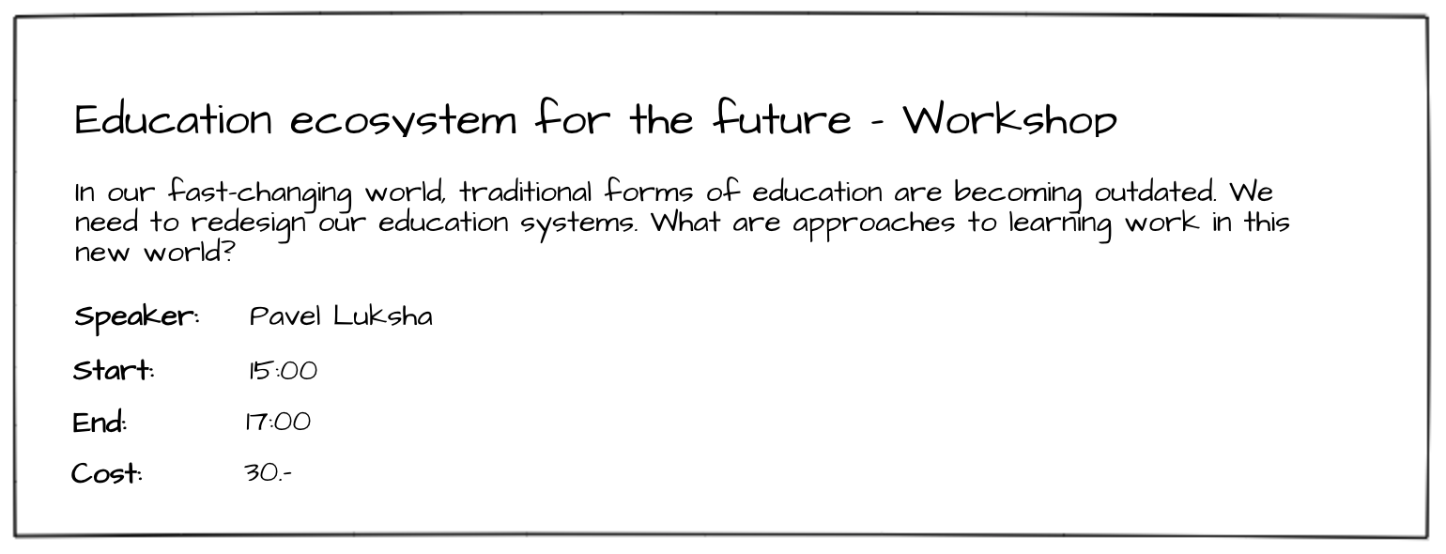
Specification: Especificação:
Feature C3 - Display session details: As an attendee, I want to inform myself about the details of a session.
Requisito C3 - Exibir detalhes da sessão: Como participante, desejo informar-me sobre os detalhes de uma sessão.

Scenario: C3a - Display session details
Given I am on an event detail page
When I click on a session
Then I see a detail page of the session containing title, description,
speaker, start and end time, type and the cost (if it is set)

Event registration Registro em Evento
After clicking on "register for this event", the user either sees the event registration form if he is logged in or gets redirected to the login form if he is not logged in.
On the event registration form, he can select the ticket type he wants. Unavailable tickets are greyed out and can't be selected. The API is responsible for this information and the validation, so it does not have to be handled in the frontend.
The user can also select additional sessions of type workshop he wants to attend. If a session has an additional cost, it will show up in the cost view and add to the total cost.
After clicking on "Purchase", the user will be registered for this event and the sessions he has selected and gets redirected back to the event detail page.
Depois de clicar em "registrar para este evento", o usuário verá o formulário de registro do evento se ele estiver logado ou for redirecionado para o formulário de login se ele não estiver logado.
No formulário de inscrição do evento, ele pode selecionar o tipo de ingresso desejado. Os ingressos indisponíveis ficam em cinza e não podem ser selecionados. A API é responsável por essas informações e pela validação, portanto, não precisa ser manipulada no frontend.
O usuário também pode selecionar sessões adicionais do tipo workshop que deseja participar. Se uma sessão tiver um custo adicional, ela aparecerá na visualização de custo e será adicionada ao custo total.
Depois de clicar em "Compra", o usuário será registrado para este evento e as sessões que ele selecionou e será redirecionado para a página de detalhes do evento.
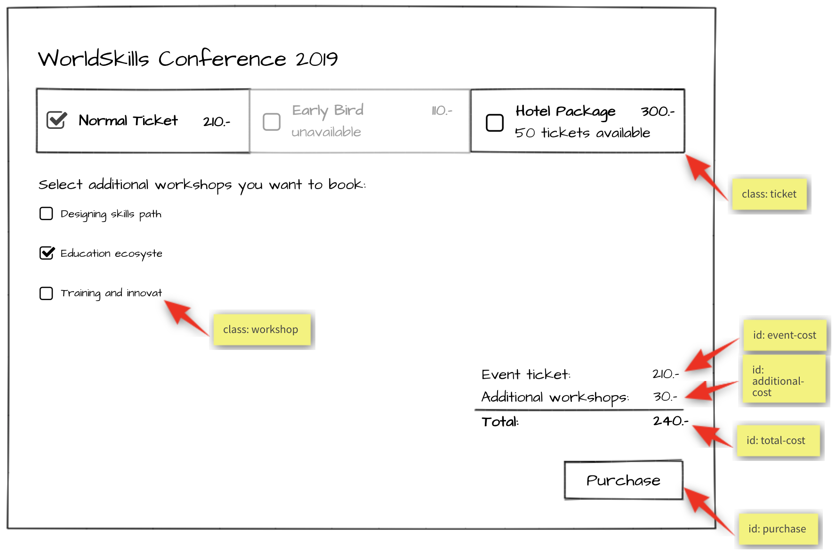
Specification: Especificação:

Feature: C4 - Register for event: As an attendee, I want to be able to register for an event and pay the admission fee.
Requisito: C4 - Registre-se para o evento: Como participante, quero poder me registrar para um evento e pagar a taxa de admissão.

Scenario: C4a - Enter registration mode
Given I am on an event detail page
And I am logged in
Then I can click on a button to enter registration mode
And I see the ticket types and their cost
And I see a checkbox list of sessions of type workshop
And I see a cost view summary
And I see a disabled "Purchase" button

Scenario: C4b - Select ticket success
Given I am in registration mode of an event
When I select a ticket that is available
Then the ticket cost is displayed in the cost view summary
And the "Purchase" button is enabled

Scenario: C4c - Select ticket fail
Given I am in registration mode of an event
When I select a ticket that is not available
Then the ticket is not selected
And the "Purchase" button is not enabled

Scenario: C4d - Select workshop session
Given I am in registration mode in an event
When I tick a workshop session
Then the session receives a tick
And the price of the workshop is displayed under "Additional workshops" in
in the cost view
And the price of the session is added to the total cost

Scenario: C4e - Purchase
Given I am in registration mode in an event
When I select a ticket and I press the "Purchase” button
Then the registration is saved
And I get redirected to the event agenda
And a message appears "Registration successful"

Attendee login Login do participante
When registering for an event, a login is required. After a successful login, the login button in the navigation should no longer be visible. Instead, the username of the currently logged in user should be displayed and a button to log out.
Ao se registrar para um evento, um login é necessário. Após um login bem-sucedido, o botão de login na navegação não deve mais estar visível. Em vez disso, o nome de usuário do usuário atualmente conectado deve ser exibido e um botão para efetuar logout.
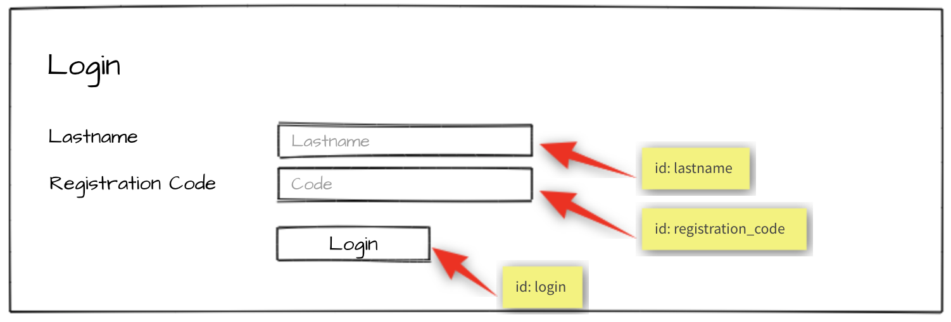
Specification: Especificação:
Feature: C5 – Log in and log out as an attendee: As an attendee, I would like to log in and log out to the event
platform so that I can access my registrations and register for new events.
Funcionalidade: C5 - Efetue login e logout como participante: Como participante, gostaria de fazer login e sair da plataforma de evento
para que eu possa acessar meus registros e se inscrever para novos eventos.

Scenario: C5a - Attendee login ok
Given I am on the "login" page
When I enter the specified lastname and registration code for an attendee
And press the "Login" button
Then I'm forwarded to the previous page
And username and "Logout" button become visible in the header

Scenario: C5b - Attendee login fail
Given I am on the "login" page
When I enter a wrong lastname and registration code for an attendee
And press the "Login" button
Then I stay on the "login" page
And I see an error message "Lastname or registration code not correct"

Scenario: C5c - Attendee logout
Given I am logged in
When I press the "Logout" button
Then I am forwarded to the "login" page
And username and logout button disappear
And I cannot reach the previous page by going back

Notes Notas
- When you are done with the first phase resp. after lunch you may continue with the second phase.
- Quando você terminar a primeira fase resp. depois do almoço você pode continuar com a segunda fase.
- If you are done with part one before the lunch break, you can start with part two by using your own API and exchange it at the start of the afternoon with the provided API.
- Se você tiver terminado a primeira parte antes do horário de almoço, você pode começar com a segunda parte usando sua própria API e trocá-la no início da tarde com a API fornecida.
- Competitors must use one of the server-side and client-side frameworks/libraries that are provided.
- Os concorrentes devem usar uma das estruturas / bibliotecas do lado do servidor e do lado do cliente que são fornecidas.
- The provided template for the admin interface should be used. It can be enhanced to get better functionality for your site. The visual design of the admin interface will not be assessed.
- O modelo fornecido para a interface administrativa deve ser usado. Pode ser aprimorado para obter melhor funcionalidade para seu site. O design visual da interface administrativa não será avaliado.
- The design of the attendee interface can be based on the template of the admin interface. The visual design of the attendee interface will be assessed: a simple, clean and attractive design is expected, including choice of colors, typography and spacing.
The design should be optimized for a minium window width of 1024px.
- O design da interface do participante pode ser baseado no modelo da interface administrativa. O design visual da interface do participante será avaliado: um design simples, limpo e atraente é esperado, incluindo escolha de cores, tipografia e espaçamento.
O design deve ser otimizado para uma largura mínima da janela de 1024 px.
- For the admin interface it is important to use the selectors (class, id) as provided in the template. For the attendee interface it is important to use the selectors (class, id) as specified in the screen mockup (yellow bubbles).
- Para a interface administrativa, é importante usar os seletores (class, id) conforme fornecidos no modelo. Para a interface do participante, é importante usar os seletores (class, id) conforme especificado no modelo de tela (bolhas amarelas).
- The specified database tables need to be implemented as provided. More tables may be added if needed. The given tables must not be changed. Provide a final SQL-dump and ERD screen as specified below.
- As tabelas de banco de dados especificadas precisam ser implementadas conforme fornecido. Mais tabelas podem ser adicionadas, se necessário. As tabelas fornecidas não devem ser alteradas. Forneça uma tela final de SQL-Dump e ERD conforme especificado abaixo.
- The API implementation should fulfill all requirements as stated in the description. All prefixes, RESTful-URLs and HTTP-Methods from the given API links must be implemented correctly and cannot be changed.
- A implementação da API deve cumprir todos os requisitos, conforme indicado na descrição. Todos os prefixos, URLs RESTful e HTTP-Methods dos links de API fornecidos devem ser implementados corretamente e não podem ser alterados.
- Changes made in the data need to be propagated between frontend and backend in both directions.
- Alterações feitas nos dados precisam ser propagadas entre frontend e backend em ambas as direções.
- Update the first two organizers in the provided dump so it is possible to login to the system during assessment:
- Atualize os dois primeiros organizadores no dump fornecido para que seja possível efetuar login no sistema durante a avaliação:
  - Organizer accounts:
  - Contas do organizador:
    - Email: demo1@worldskills.org Password: demopass1
    - Email: demo2@worldskills.org Password: demopass2
- For the room capacity bar chart, you can use one of the provided JS-libraries (Charts.js, D3.js)
- Para o gráfico de barras de capacidade de sala, você pode usar uma das bibliotecas JS fornecidas (Charts.js, D3.js)

Submission Instructions to the Competitor
Instruções do competidor para o envio
Morning: Files to be collected after the first phase on the server:
Manhã: Arquivos a serem coletados após a primeira fase no servidor:
- Web service (http://<hostname>/XX_JS-PHP_A/api/v1/..)
- Admin area (http://<hostname>/XX_JS-PHP_A/) - initially shows login page
- Folder inside webroot (XX_JS-PHP_A/)
- ERD screenshot named “XX_ERD.png” in “db-dump” folder inside of XX_JS-PHP_A
- Database dump named “XX_database.sql” in “db-dump” folder inside of XX_JS-PHP_A

Afternoon: Files to be collected after the second phase on the server:
Tarde: Arquivos a serem coletados após a segunda fase no servidor:
- Front-end website (http://<hostname>/XX_JS-PHP_B/)
- Folder inside webroot (XX_JS-PHP_B/) - put all development files into XX_JS-PHP_B_dev.zip and leave only files for production-use in this directory.
- If the front-end root (http://<hostname>/XX_JS-PHP_B) does not open the main page directly, have it open an index.html with a link to the main page for marking your front-end.
XX is your country code

The Web Service / REST-API will be assessed with the automated test-framework provided. Additional data may be used to test dynamic behavior.
It is recommended that you run the automated tests for the REST-API after implementing it locally or at least after uploading it to the server. Instructions to setup and use the tests for the API: see README.md in tests_api-php.
Manual assessment of other parts will be done using Google Chrome.
O Web Service / REST-API será avaliado com a estrutura de teste automatizada fornecida. Dados adicionais podem ser usados para testar o comportamento dinâmico.
Recomenda-se que você execute os testes automatizados para a API REST após implementá-la localmente ou pelo menos depois de carregá-la no servidor. Instruções para configurar e usar os testes para a API: consulte README.md em tests_api-php.
A avaliação manual de outras partes será feita usando o Google Chrome.

Equipment, machinery, installations, and materials required
Equipamento, máquinas, instalações, e materiais necessários
It is expected that all Test Projects can be accomplished by Competitors based on the equipment and materials specified in the Infrastructure List*.
If any equipment or material is required that is not listed in the Infrastructure List, then it has to be listed here (in the table below - column headings may vary from skill to skill.)
WorldSkills International needs to approve any additional infrastructure requirements that are not listed in the Infrastructure List. Column headings may vary from skill to skill.
* (Definition: the Infrastructure List is the equipment, machinery, installations and materials supplied by the host country – it does not include tools and material to be supplied by Competitors and/or Experts)
Espera-se que todos os Projetos de Teste realizados pelos Concorrentes com base nos equipamentos e materiais especificados na Lista de Infraestrutura *.
Se for necessário algum equipamento ou material que não esteja listado na Lista de Infraestrutura, ele deverá ser listado aqui (na tabela abaixo - os títulos das colunas podem variar de habilidade para habilidade.)
A WorldSkills International precisa aprovar quaisquer requisitos adicionais de infraestrutura que não estejam listados na Lista de Infraestrutura. Os títulos das colunas podem variar de habilidade para habilidade.
* (Definição: a Lista de Infraestrutura é o equipamento, maquinaria, instalações e materiais fornecidos pelo país anfitrião - não inclui ferramentas e material a serem fornecidos pelos Concorrentes e / ou Especialistas)

ITEM | description
Media Files | Contains: Contém:  - DB dump  - Template files for the admin-gui  - Charts.js & D3.js incl. Documentation  - Files for testing REST-API

Marking Scheme Ficha de Avaliação
SECTION | CRITERION | JUDG. MARKS | MEAS. MARKS | TOTAL
C1 | Database | 1.75 | 1.5 | 3.25
C2 | Admin Backend | 0 | 3.25 | 3.25
C3 | Ticket and Session | 0 | 1.5 | 1.5
C4 | Organizer | 1 | 2.25 | 3.25
C5 | REST API | 1.5 | 2.25 | 3.75
D1 | Events list and agenda | 0 | 3.75 | 3.75
D2 | Session and Events | 0 | 3 | 3
D3 | General | 1 | 3 | 4
D4 | JS Quality | 2.5 | 0 | 2.5
D5 | Front end design | 3 | 0 | 3
TOTAL |  | 10.75 | 20.5 | 31.25

